Sample Participant Letter to Healthcare Provider

[AGENCY LETTERHEAD] ______________________________________________________________________________
[AGENCY]
[AGENCY ADDRESS]
[AGENCY CONTACT INFORMATION]
Living Well with Diabetes Workshop

Date: ____________________________
Dear _____________________________________,
I participated in the Living Well with Diabetes Workshop on
_________________________________________ at
(DATES OF WORKSHOP)

__________________________________________.
(LOCATION OF WORKSHOP)

In this workshop I learned how to cope with frustration associated with my diabetes. Some of the issues discussed were reading food labels, healthy nutrition, preventing or delaying complications, exercise, and appropriate use of medications. I also learned how to set realistic goals for improving my health by using a weekly “action plan” throughout the six week workshop.
During the program, I accomplished:

My current action plan is:

Please file this in my medical record and ask me about it at my next visit. Thank you.
Sincerely,
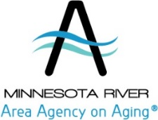

For more information about this and other programs visit WWW.MNRAAA.ORG.

